Name: Roshan Joshi
Student Number: 240236

This is index page
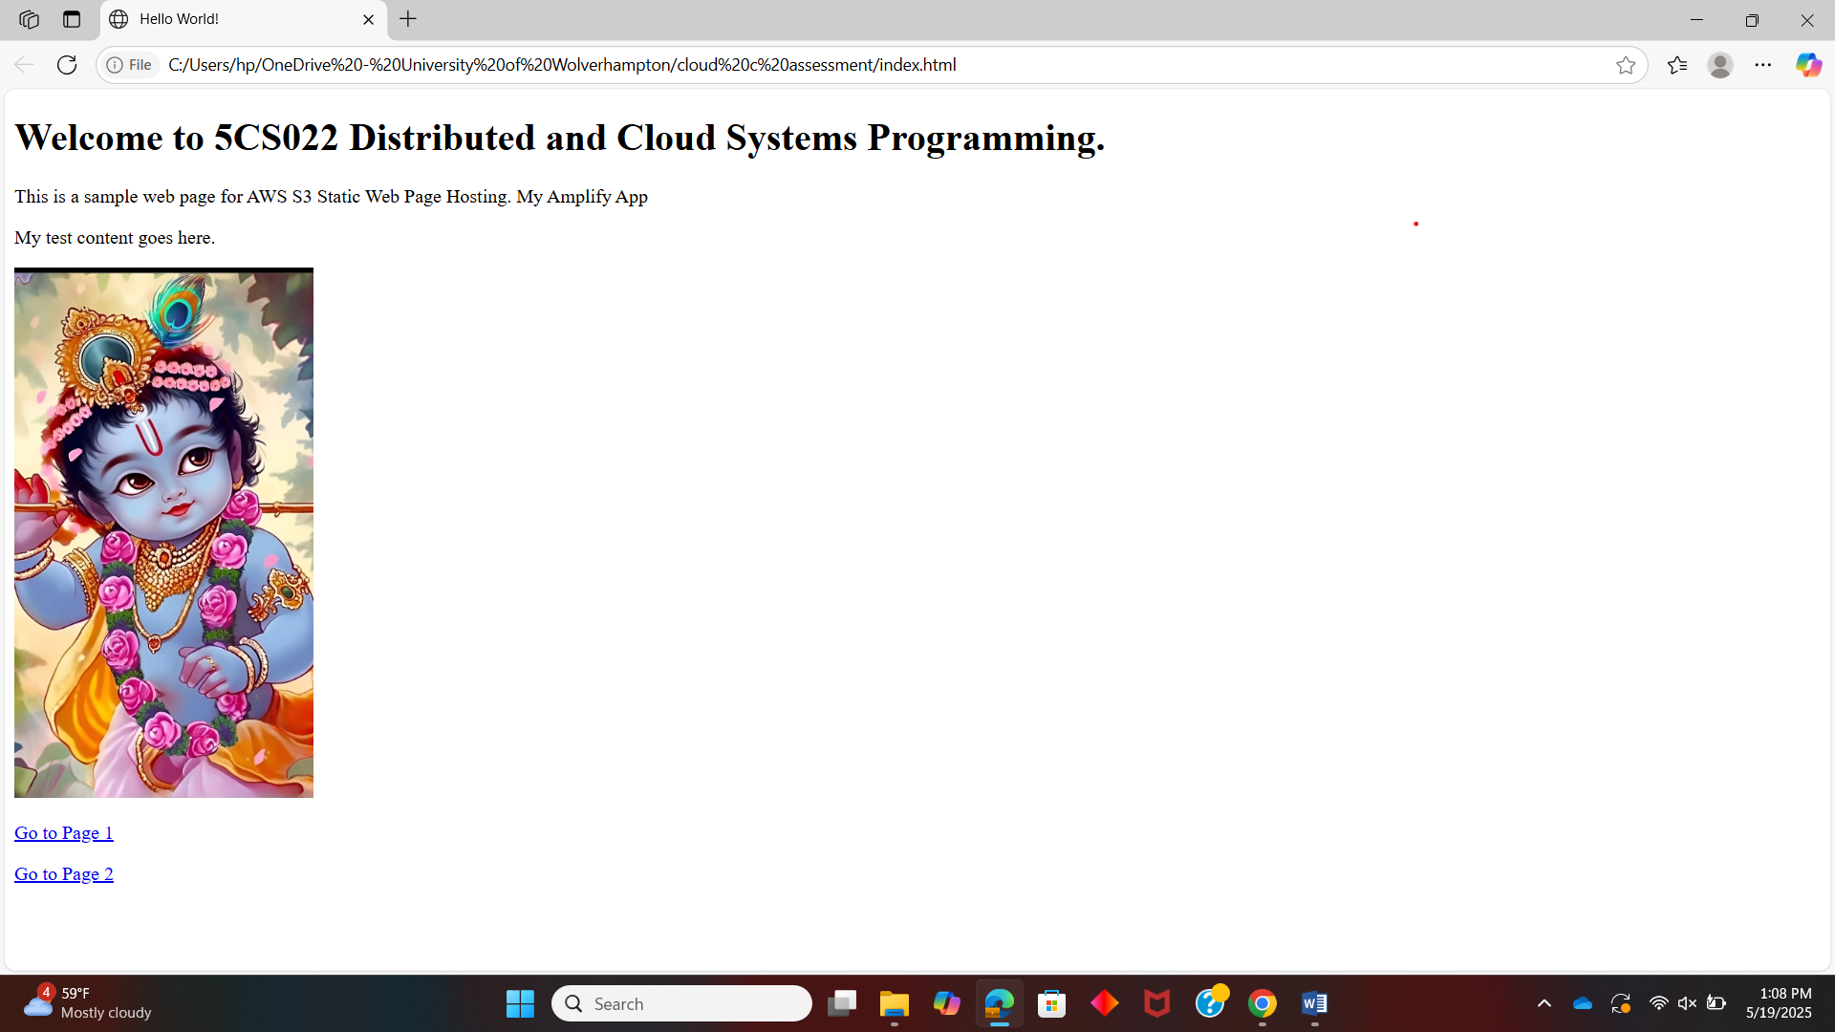

This is amplify page 1
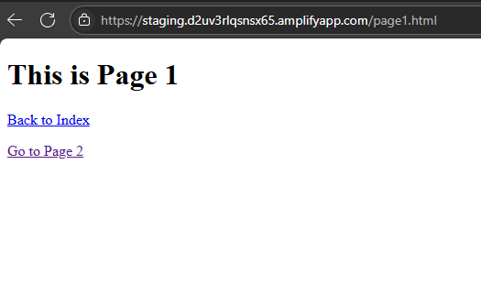
This is amplify page 2

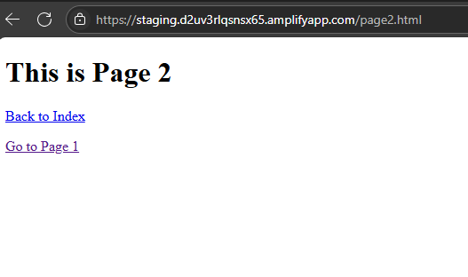
This is amplify image of lord Krishna
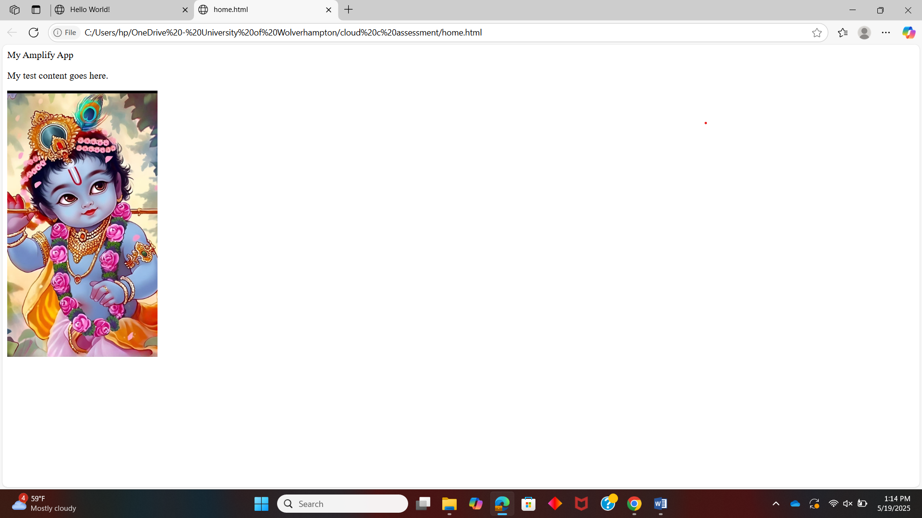

This is just to show I completed whole workshop to do this. Cheers!
